Procedures for the enrolment of students in Bulli High School
Informed by Enrolment of Students in NSW Government Schools Policy statement
at https://education.nsw.gov.au/policy-library/policies/enrolment-of-students-in-nsw-government-schools and General Enrolment Procedures at https://education.nsw.gov.au/policy-library/associated-documents/pd-2002-0006-01.pdf

Students are entitled to be enrolled at the local school for which they are eligible. The school finder tool is located at https://education.nsw.gov.au/school-finder

Decision tree for standard enrolments
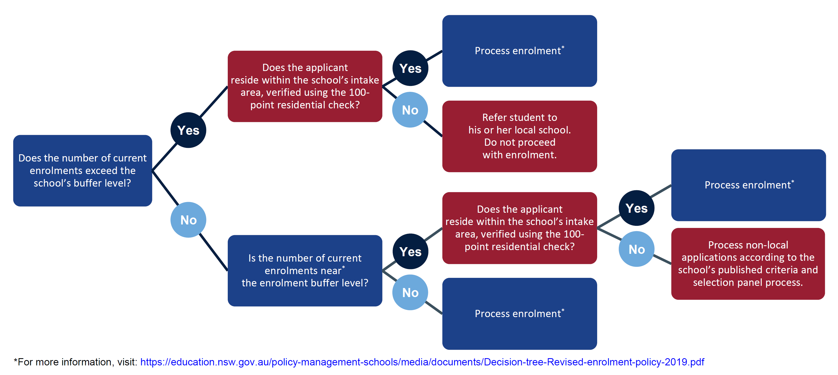
https://education.nsw.gov.au/policy-management-schools/media/documents/Decision-tree-Revised-enrolment-policy-2019.pdf

Enrolment Cap
The enrolment cap is the number of students that can be enrolled at a school based on permanent accommodation. The cap is determined centrally by School Infrastructure NSW.

Enrolment Buffer
Within the enrolment cap, a number of enrolment places (a buffer) must be set aside for the enrolment of local students arriving throughout the year. Once a school has reached its local enrolment buffer, places cannot be offered to non-local students. The local enrolment buffer and the school’s non-local enrolment criteria are to be reviewed on a regular basis. Any change is to be approved by the Director, Educational Leadership in time for enrolment of the following year’s intake.

Proof of residency
Schools will undertake a 100 point check to verify that a student presenting for enrolment resides within the school’s designated intake area. In exceptional circumstances, the principal may waive this requirement subject to approval by the Director, Educational Leadership.

Enrolment of non-local students
Schools that have reached their enrolment cap have no capacity to enrol non-local students unless requested by the Director, Educational Leadership.

Criteria for the enrolment of non-local students may include:
- siblings already enrolled at the school
- compassionate circumstances
- medical reasons
- safety and supervision of the student before and after school
- availability of subjects or combinations of subjects
- structure and organization of the school
- proximity and access to the school
- recent change in the local intake area boundaries

Criteria for the enrolment of non-local students will not include student ability, performance or achievement.

Wollongong North Network high school enrichment classes
All Wollongong North high schools offer an enrichment class to high potential or gifted students. Only students who have been accepted for enrolment can be considered for enrichment class placement.

While criteria are applied to the formation of each Wollongong North high school’s enrichment class, the classes are not designated as Selective classes, nor are the schools identified as partially Selective.

Responding to non-local enrolment applications
When a principal receives a non-local enrolment application, the principal will inform the principal of the student’s local school.

Principals will ensure relevant staff know whether they can or cannot accept non-local enrolments and ensure advice and communication provided to parents is consistent. Principals will also develop protocols, in collaboration with other schools if appropriate, to ensure communications and advice provided to parents is consistent and supportive of public education. This may including requesting a parent to attend at the local school and to meet that school’s principal before any non-local enrolment application is considered.

Procedures for non-local enrolment applications can be found at: https://education.nsw.gov.au/public-schools/going-to-a-public-school/enrolment

Enrolment panels
Schools above their buffer cannot enrol non-local students, without the approval of the Director, Educational Leadership.

When the number of non-local applications received exceeds the number of places available below the local enrolment buffer, applications will be considered by a non-local enrolment panel. The principal will also seek the approval of the Director, Educational Leadership before agreeing to enrol the student.

The enrolment panel includes:
- A member of the executive staff (chairperson)
- A member of the school’s teaching staff
- School community member, nominated by the school’s Parents and Citizens’ Association

The preference is for the principal not to be part of the enrolment panel so that any appeal can be considered by the principal in the first instance.

Waiting Lists
Where no non-local places are available within the school’s buffer, a waiting list for students may be established by the principal. The length of the waiting list should reflect realistic expectations of potential vacancies and ensure students can participate in the relevant transition processes.

Appeals
Appeals against the decline of non-local enrolment applications must be in writing. They are managed by the principal in the first instance with the purpose to determine whether the stated criteria have been applied equitably.

The Director, Educational Leadership is the final decision maker for appeals against the decline of non-local enrolment applications as per the General Enrolment Procedures (at https://education.nsw.gov.au/policy-library/associated-documents/pd-2002-0006-01.pdf).

Helensburgh Public School
On 19 August 2019 the Department of Education confirmed that Heathcote High School remains the local high school for families residing in Helensburgh, but by way of transition and acknowledging previous lack of clarity provided by the department, any student currently enrolled at Helensburgh Public School and their siblings can apply to enrol at either Heathcote High School or Bulli High School.

In the future, any new family living in Helensburgh township who seeks enrolment at Helensburgh Public School will be subject to the normal enrolment policy (2019) when they subsequently submit application for enrolment at high school. They will be required to apply for non-local enrolment at Bulli High School if this is the secondary school they wish their child to be considered for.

